Name:__________________ ( ) F.4 ____ Chapter 13 Reproduction in flowering plants
Table showing the adaptive features of a Gladiolus flower to its way of pollination

Floral parts | Features | Adaptation
Sepal ( ) |  | ------------------------------------------
Petal ( )
(Insect guide present?)

Stamen ( )

Carpel ( )

Scent | Present / absent
Nectary | Present / absent

Gladiolus flower is ____________- pollinated

On the photo of the dissected flower, label the following floral parts:
Sepal, petal, stamen, anther, filament, carpel, stigma, style, ovary, ovule.

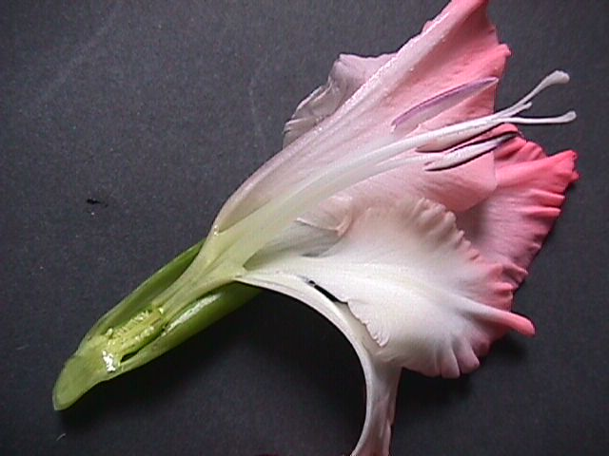

Table showing the adaptive features of a Lily flower to its way of pollination

Floral parts | Features | Adaptation
Sepal ( ) |  | ------------------------------------------
Petal ( )
(Insect guide present?)

Stamen ( )

Carpel ( )

Scent | Present / absent
Nectary | Present / absent

Lily flower is ____________- pollinated

Take of photo of the dissected flower and label the following floral parts:
Sepal, petal, stamen, anther, filament, carpel, stigma, style, ovary, ovule.

